
SRM Institute of Science and Technology
Mode of Exam
OFFLINE
College of Engineering and Technology
School of Computing
DEPARTMENT OF COMPUTING TECHNOLOGIES
SRM Nagar, Kattankulathur – 603203, Chengalpattu District, Tamilnadu
Academic Year: 2022-2023 (ODD)
Test: CLAT-3 SET-B Date: 02.11.2023
Course Code & Title: 18CSE453T NETWORK ROUTING ALGORITHMS Duration: 12.30PM - 2.15PM
Year & Sem: III / IV & V / VII Max. Marks: 50

Course Articulation Matrix: (to be placed)

S.No. | Course Outcome | PO1 | PO2 | PO3 | PO4 | PO5 | PO6 | PO7 | PO8 | PO9 | PO10 | PO11 | PO12
1 | CO1 | H |  | M |  |  |  |  |  |  |  |  | M
2 | CO2 |  | M | L |  | H
3 | CO3 |  | H | L | H
4 | CO4 | M | H | H
5 | CO5 |  | H |  | H | H
6 | CO6. |  | H |  | H | H

Part - A
( 10 x 1 =10 Marks)
Instructions: Answer all
Q. No | Question | Marks | BL | CO | PO | PI Code
1 | RIPv2 send the entire routing table to all connected routers at the multicast address _______.  - 225.255.255.255  - 224.0.0.9  - 225.0.0.9  - 224.0.0.10 | 1 | 1 | 4 | 1 | 1.6.1
2 | Default holddown time for RIP is ?  - 600 sec  - 120 sec  - 160 sec  - 180 sec | 1 | 1 | 4 | 1 | 1.6.1
3 | Enhanced IGRP (EIGRP) is ?  - Class full routing  - Classless routing  - Both a & b  - Broad cast | 1 | 1 | 4 | 1 | 1.6.1
4 | Which of the following algorithm is used by OSPF to determine the best path from source to destination?  - Bellmon Ford algorithm  - Diffusing update algorithm  - Dijkstra’s algorithm  - Swan Optimization | 1 | 2 | 4 | 2 | 1.6.1
5 | Which one of the following statements is true that could identify with pure flooding?  a. every node transmits the request only once  b. every node broadcast the request only once  c. every node forwards the request multiple times  d. every node broadcasts the request multiple times | 1 | 1 | 4 | 1 | 1.7.1
6 | As given from the graph,  Assume, link C-D fails, and node A does not know about it (route error packet from C is lost).  C performs a route discovery for D. Which one of the following options provides the path on how Node A receives the route request?  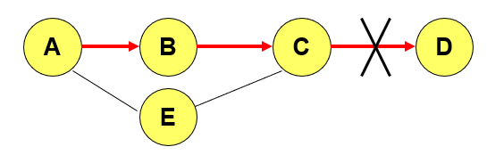  a. C-B-A  b. C-E-A  c. C-B-A-E  d. C-E-A-B-C | 1 | 3 | 5 | 3 | 3.7.1
7 | Which answer is wrong about The routing protocols for ad hoc wireless networks can be broadly classified into  - Routing information update mechanism  - Use of temporal information for routing  - Routing topology  - Hardware used | 1 | 1 | 5 | 1 | 1.6.1
8 | Which one is the first protocols proposed for adhoc wireless networks?  - Wireless routing protocol(WRP)  - Destination sequenced distance-vector routing  - Source-tree adaptive routing protocol (STAR)  - Dynamic source routing protocol | 1 | 1 | 5 | 1 | 1.6.1
9 | Which among these is not the table driven routing protocols  - Destination sequenced Distance Vector routing protocol  - Ad-Hoc On Demand Distance Vector routing protocol  - Wireless Routing Protocol  - Destination Sequenced Routing | 1 | 1 | 5 | 1 | 1.6.1
10 | Which protocol would have the responsibilities of forwarding of a route request?  a. Intra zone Routing Protocol (IARP)  b. Inter zone Routing Protocol (IERP)  c. Broadcast Resolution Protocol (BRP)  d. Neighbor Discovery Protocol (NDP) | 1 | 1 | 5 | 1 | 1.7.1
Part – B
( 4 x 10 = 40 Marks)
Instructions: Answer ALL
11.a | Compare header format of RIPv1 with RIPv2.  State the advantages of RIPv1 and RIPv2  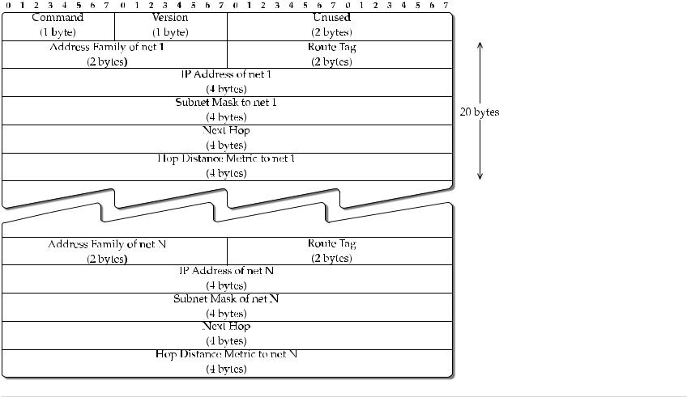  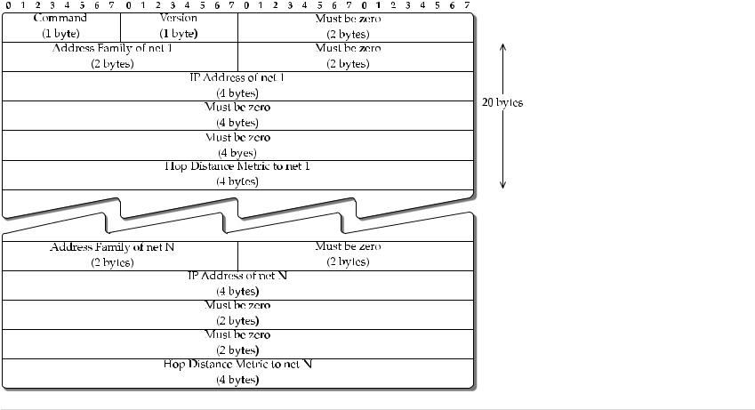  The main advantage of RIP is that its bandwidth utilization is very high and it updates every 30 second | 10 | 1 | 4 | 1 | 1.6.1
 | (OR)
11.b | Explain about EIGRP and its header format  EIGRP is another routing protocol from Cisco  it is a simple enhancement of IGRP.  The one thing in common between IGRP and EIGRP is the composite metric.  Although EIGRP is also from the distance vector protocol family, in many ways it is completely different from protocols such as RIP and IGRP.  A major difference is that EIGRP provides loop-free routing  EIGRP includes a hello protocol for neighbour discovery and recovery, and a reliable transfer mechanism for exchange of distance vector data.  - EIGRP is provided directly over IP using protocol number 88.  - all EIGRP related message communication is multicast on the address 224.0.0.10;  - acknowledgments are unicasted.  - Since EIGRP requires reliable delivery, and given that the protocol is built directly over IP and multicast addressing is used, a reliable multicast mechanism is used.  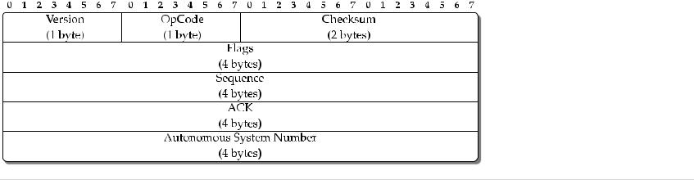 | 10 | 1 | 4 | 1 | 1.6.1
12.a | Explain about Integrated IS-IS  Intermediate System to Intermediate System (IS-IS, also written ISIS) is a routing protocol designed to move information efficiently within a computer network, a group of physically connected computers or similar devices. It accomplishes this by determining the best route for data through a packet switching network.  IS-IS is an interior gateway protocol, designed for use within an administrative domain or network. This is in contrast to exterior gateway protocols, primarily Border Gateway Protocol (BGP), which is used for routing between autonomous systems (RFC 1930).  IS-IS is a link-state routing protocol, operating by reliably flooding link state information throughout a network of routers. Each IS-IS router independently builds a database of the network's topology, aggregating the flooded network information. Like the OSPF protocol, IS-IS uses Dijkstra's algorithm for computing the best path through the network. Packets (datagrams) are then forwarded, based on the computed ideal path, through the network to the destination. | 10 | 1 | 4 | 1 | 1.7.1
 | (OR)
12.b | Explain Traffic Engineering: A Four-Node Illustration neatly  Traffic engineering is a method of optimizing the performance of a telecommunication network by dynamically analyzing, predicting, and regulating the behavior of data transmitted over that network.  The most important objective is to reduce accidents with considerable speed and the pedestrian should be considered as an element not obstruction. | 10 | 1 | 4 | 1 | 1.7.1
13.a | Define Table Driven Routing Protocol and explain any one of the Protocol comes under this category  Destination sequenced distance vector routing protocol (DSDV)  Modification of the Bellman-Ford algorithm where each node maintains:  - the shortest path to destination;  - the first node on this shortest path.  This protocol is characterized by the following:  - routes to destination are readily available at each node in the routing table (RT);  - RTs are exchanged between neighbors at regular intervals;  - RTs are also exchanged when significant changes in local topology are observed by a node.  RT updates can be of two types:  - incremental updates:  - take place when a node does not observe significant changes in a local topology;  - full dumps:  - take place when significant changes of local topology are observed; | 10 | 2 | 5 | 2 | 2.1.2
 | (OR)
13.b | Elaborate about AODV & compare it with DSR Protocol  The AODV protocol performs as follows:  - when a node does not have a valid route to destination a RouteRequest is forwarded;  - when intermediate node receives a RouteRequest packet two cases are possible:  - if it does not have a valid route to destination, the node forwards it;  - if it has a valid route, the node prepares a RouteReply message:  - if the RouteRequest is received multiple times, the duplicate copies are discarded:  - are determined comparing BcastID-SrcID pairs.  - when RouteRequest is forwarded, the address of previous node and its BcastID are stored;  - are needed to forward packets to the source.  - if RouteReply is not received before a time expires, this entry is deleted;  - either destination node or intermediate node responses with valid route;  - when RouteRequest is forwarded back, the address of previous node and its BcastID are stored;  - are needed to forward packets to the destination.  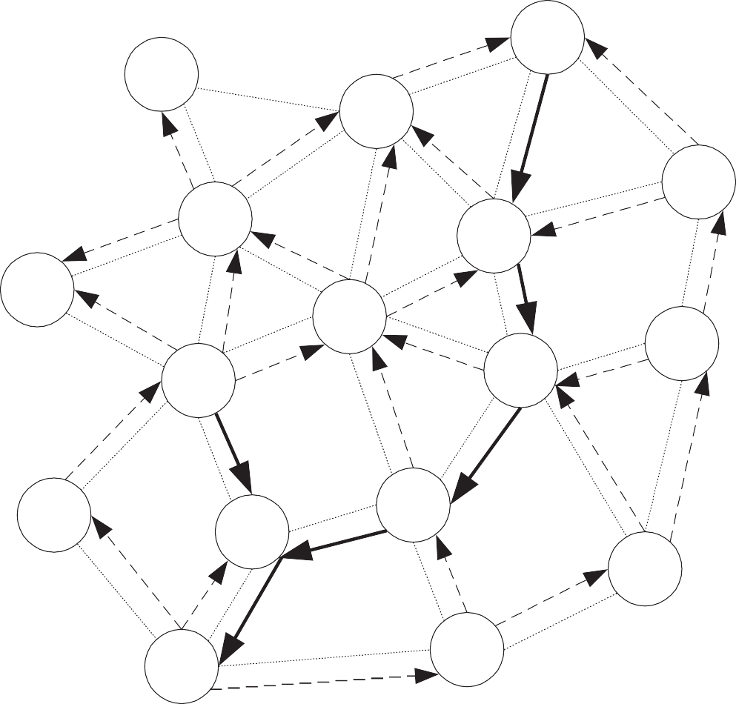  RouteRequest:  - DestSeqNum:5,  - SrcSeqNum: 2  Node 8:  - DestSeqNum 3;  Node 9:  - DestSeqNum 7; | 10 | 2 | 5 | 2 | 2.1.2
14.a | Explain the PSTN Call Routing using the Internet with neat diagram  Public Switch Telephone Network was basically developed and engineered for giving voice connectivity to the wire line subscribers.  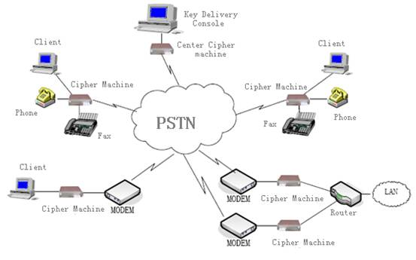 | 10 | 2 | 5 | 2 | 2.1.2
 | (OR)
14.b | Power-Aware Routing Protocols with examples  - Power-aware routing protocols  The following metrics can be taken into account on route selection procedure:  - Minimal energy consumption per a packet:  This metric involves a number of nodes from source to destination.  – +: uniform consumption of power throughout the network;  - Maximize the network connectivity:  To balance the load between the cut-sets (those nodes removal of which causes partitions).  – −: difficult to achieve due to variable traffic origination.  - Minimum variance in node power levels:  To distribute load such that power consumption pattern remains uniform across nodes.  – +: nearly optimal performance is achieved by routing a packet to least loaded next-hop.  - Minimum cost per a packet:  Cost as a function of the battery charge (less energy – more cost) and use it as a metric.  – +: easy to compute (battery discharge patterns are available);  – +: this metric handles congestions in the network. | 10 | 2 | 5 | 2 | 2.1.2

*Performance Indicators are available separately for Computer Science and Engineering in AICTE examination reforms policy.

Course Outcome (CO) and Bloom’s level (BL) Coverage in Questions

